BottomSheet with Tabbar
Exercise #1
Flutter Developer Bootcamp

Purpose
This exercise demonstrates how to implement a bottom sheet in a Flutter application using the showModalBottomSheet function and Tab bar view.
Problem
In the provided Exercise You need to create as follows:
In the given exercise showcases a tabbed interface with three tabs: "Chats", "Calls", and "Settings". Each tab displays its respective content, with the "Chats" tab demonstrating a button that triggers a modal bottom sheet. The bottom sheet presents a simple layout with a height of 200 and an amber background, containing a "Modal BottomSheet" text and a button to close it. This setup effectively demonstrates the implementation of a bottom sheet within a Flutter application.
How to Solve
1. Checkout the exercise from Git Repo:
git clone -b <user-branch> <repo-URL>
2. Open the root folder inside VS Code
3. To build the app click the run option in the main method{}
4. Define Tabs: Define the tabs you want to include in your application. You can use the TabBar and TabBarView widgets to create a tabbed interface. Each tab will have its own content.

5. Add Content for Each Tab: Define the content for each tab. This can include widgets like Text, ListView, GridView, or custom widgets depending on your requirements.

6. Implement Modal Bottom Sheet: For the tab that should trigger a modal bottom sheet, create a button or any other user interaction that, when pressed, invokes the showModalBottomSheet function. Inside the builder function of showModalBottomSheet, define the content of your modal bottom sheet.

8. Customize Appearance: Customize the appearance of your tabs, app bar, and bottom sheet as needed. You can adjust colors, fonts, and other visual properties to match your design.

9. Go To File: <specific-file-with-bottomsheet-method> à <method-name>, implement your logic.

You will Achieve
When you complete this Exercise you will learn the following:
- Tabbed Interface: Implement a tabbed interface with three tabs: "Chats", "Calls", and "Settings". This is achieved using the DefaultTabController, TabBar, and TabBarView widgets.

- Bottom Sheet Functionality: Implement a bottom sheet that appears when a button is pressed. The bottom sheet contains a brief message and a button to close it. This is accomplished using the showModalBottomSheet function.

- Widget Imports:

- MaterialApp: For setting up the root widget of the application.
- DefaultTabController: To manage the tab controller for the tabbed interface.
- Scaffold: Provides the basic material design visual layout structure.
- AppBar: Represents the app bar at the top of the screen.
- TabBar: Displays a horizontal row of tabs.
- TabBarView: Displays the content corresponding to each tab.
- Center: Centers its child within itself.
- ElevatedButton: A button with a filled background color.
- Text: Displays text.
- showModalBottomSheet: Displays a modal bottom sheet.
By incorporating these widgets and functionalities, you'll create a Flutter application with a tabbed interface and modal bottom sheet functionality.

Screenshots

Expected output(with bottomsheet and tab bar)
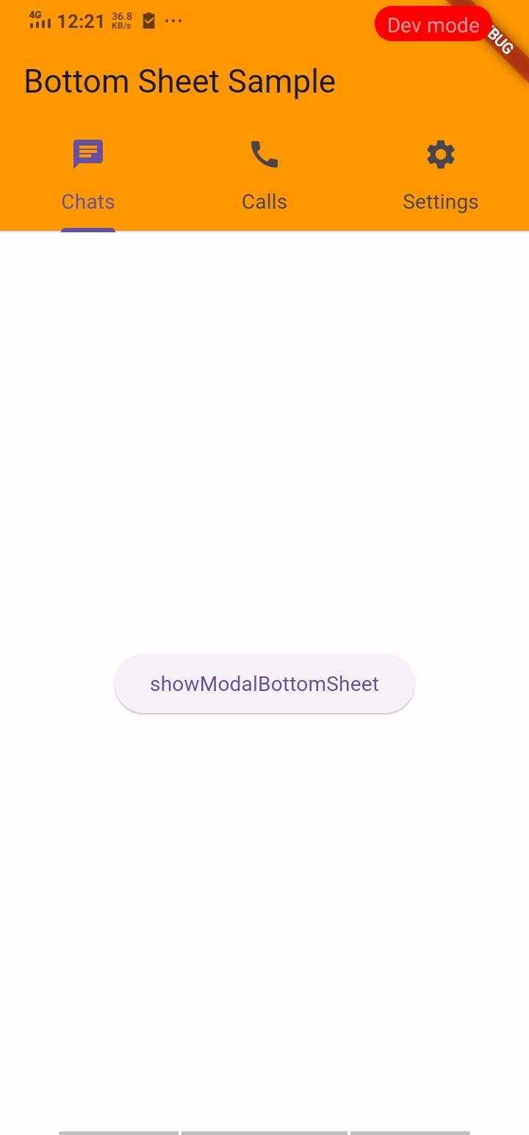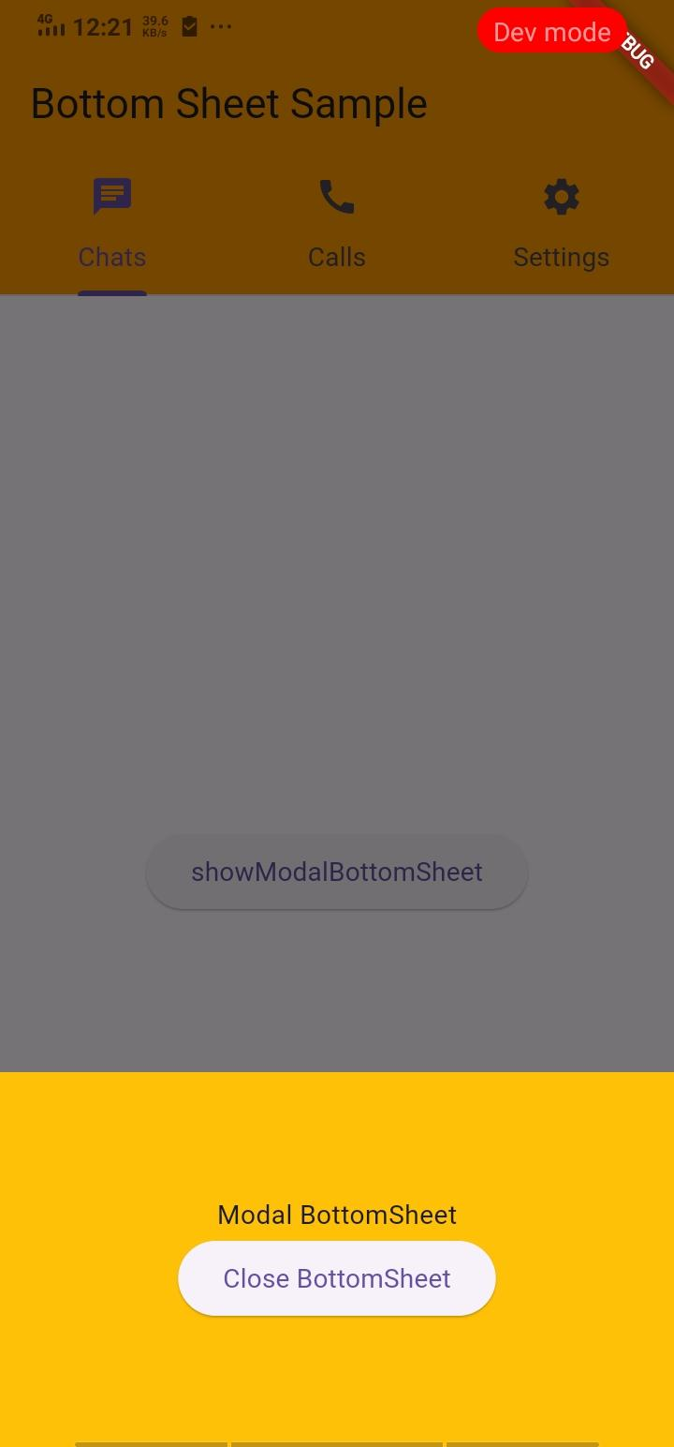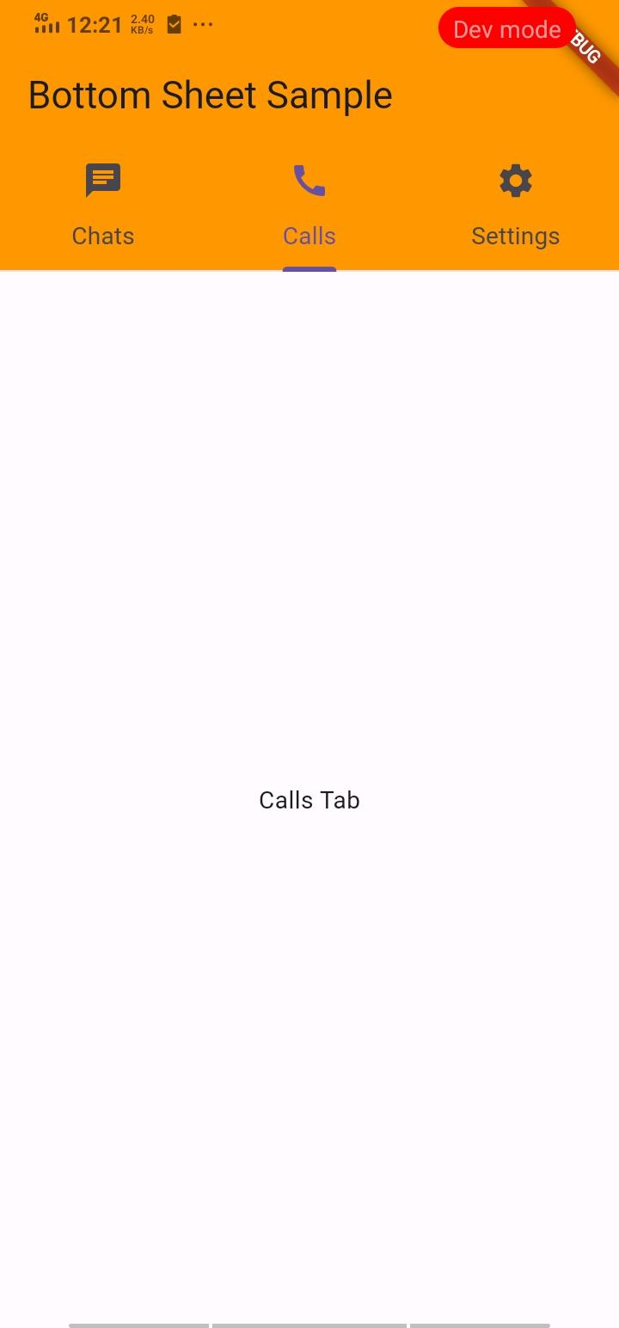me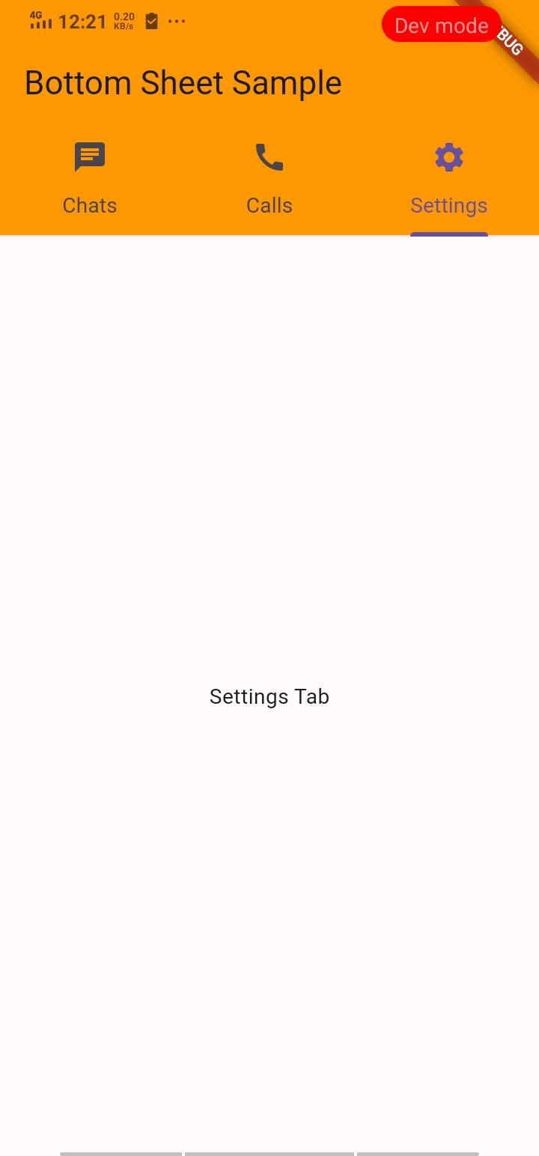

How to submit your Exercise
Push your project back to the same git branch using command:
<command name>

Happy Coding!

